**AUTONOMOUSE UNDERWATER VEHICLE SPECIFICATION**

Company Name: **Kongsberg Maritime**

AUV Name: **HUGIN 1000 AUV**

SPECIFICATION:

Developed by Kongsberg Maritime in collaboration with the Norwegian Defence Research Establishment (FFI), the HUGIN 1000 is designed for operations at depths up to 1,000 meters. Measuring 4.5 meters in length and weighing between 650kg and 850kg, it features a modular design allowing for various payload configurations. The AUV is equipped with advanced sensors, including multi-beam echo-sounders, side-scan sonars, and sub-bottom profilers, making it suitable for applications such as mine countermeasures, rapid environmental assessment, and route surveying.

|  |  |  |  |  |  |  |
| --- | --- | --- | --- | --- | --- | --- |
| Maximum Depth | Length | Height | width | Speed | Propulsion Type | Weight |
| 1,000 meters | 4.5 meters | 0.2 meters | 0.2 meters | 2 to 6 Knots | Electric | 650kgs to 850kgs |

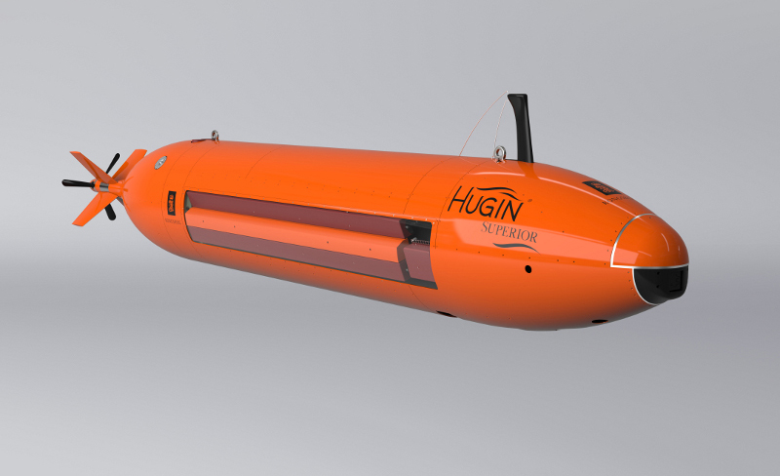

Company Name: **Teledyne Marine**

AUV Name: **Gavia AUV**

SPECIFICATION:

Produced by Teledyne Marine, the Gavia AUV is a modular, self-contained survey platform with depth ratings of 500m or 1,000m, depending on configuration. Its modularity allows for easy reconfiguration between dives, enabling it to serve multiple purposes without compromising performance or data quality. The Gavia is utilized in military, commercial, and scientific applications worldwide.

|  |  |  |  |  |  |  |
| --- | --- | --- | --- | --- | --- | --- |
| Maximum Depth | Length | Height | width | Speed | Propulsion Type | Weight |
| 1,000 meters | 2.7 meters | 0.2 meters | 0.2 meters | 4 Knots | Electric | 77 kgs |

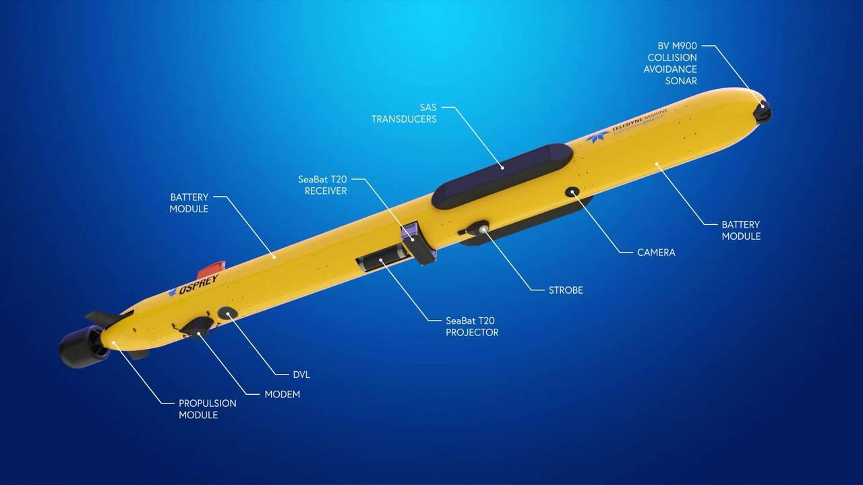

Company Name: **Russia's Central Design Bureau for Marine Engineering (RUBIN)**

AUV Name: **Vityaz-D AUV**

SPECIFICATION:

Developed by Russia's Central Design Bureau for Marine Engineering (RUBIN), the Vityaz-D is an autonomous underwater vehicle capable of reaching depths up to 12,000 meters. In May 2020, it reached the bottom of the Mariana Trench, performing an autonomous mission based on a pre-installed program. The vehicle measures 5.7 meters in length, 1.3 meters in diameter, and weighs 5.7 tons. It is equipped with artificial intelligence for obstacle avoidance and confined space navigation, as well as various sensors, including photo/video cameras and side-scan sonar.

|  |  |  |  |  |  |  |
| --- | --- | --- | --- | --- | --- | --- |
| Maximum Depth | Length | Height | width | Speed | Propulsion Type | Weight |
| 12,000 meters | 5.7 meters | 1.3 meters | 1.3 meters | 3 Knots | Electric | 5.7 tons |



Company Name: **Boeing**

AUV Name: **Orca**

SPECIFICATION:

The **Orca Extra Large Unmanned Underwater Vehicle (XLUUV)** is a large-scale AUV developed by **Boeing** in collaboration with **Huntington Ingalls Industries** for the **United States Navy**. The Orca can operate autonomously for several months without human intervention and has a maximum operational depth of **6,000 meters.** Measuring **15.5 meters** in length, **2.6 meters** in diameter, and weighing approximately **50 tons,** the Orca is designed for undersea reconnaissance, surveillance, and data collection missions. It is equipped with modular payload bays to carry different types of mission payloads

|  |  |  |  |  |  |  |
| --- | --- | --- | --- | --- | --- | --- |
| Maximum Depth | Length | Height | width | speed | Propulsion Type | Weight |
| 6,000 meters | 15.5 meters | 2.6 meters | 2.6 meters | 8 knots | Fuel | 50 tons |

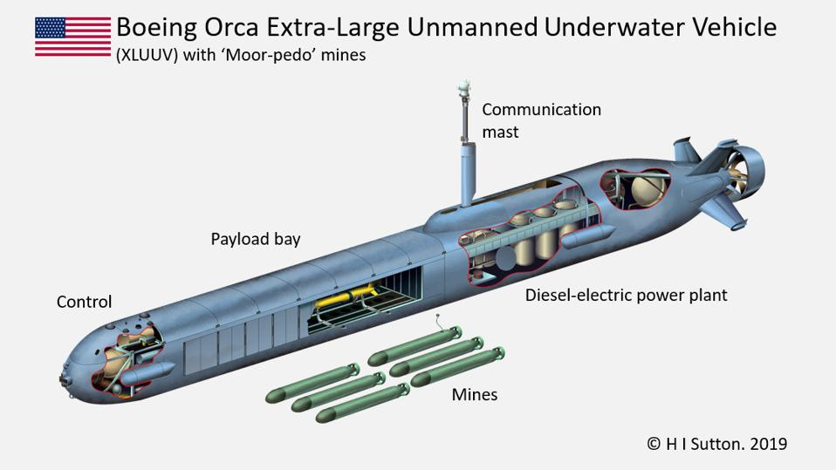

Company Name: **Bluefin Robotics**

AUV Name: **Bluefin-21**

SPECIFICATION:

The **Bluefin-21** is a deep-water Autonomous Underwater Vehicle designed and manufactured by **Bluefin Robotics**. It has an operational depth of **4,500 meters**, a length of **4.93 meters**, a diameter of **0.53 meters**, and weighs around **750 kg**. The Bluefin-21 is widely used for deep-sea survey missions, ocean mapping, and search-and-rescue operations. It was famously deployed in the search for **Malaysia Airlines Flight MH370**. The AUV is equipped with multi-beam sonar, side-scan sonar, and high-resolution imaging systems.

|  |  |  |  |  |  |  |
| --- | --- | --- | --- | --- | --- | --- |
| Maximum Depth | Length | Height | width | speed | Propulsion Type | Weight |
| 4,5000 meters | 4.93 meters | 0.53 meters | 0.53 meters | 4.5 knots | Electric | 750kgs |

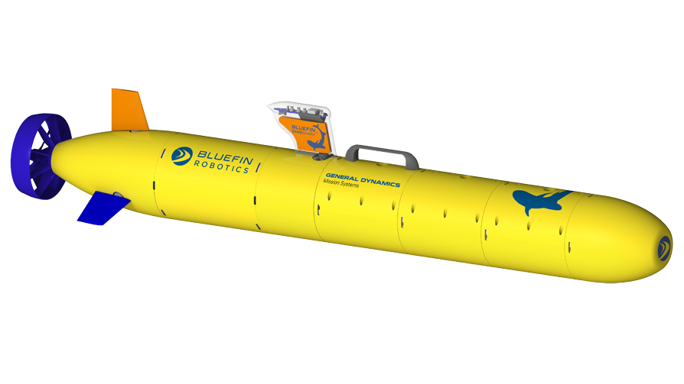

Company Name: **Woods Hole Oceanographic Institution**

AUV Name: **Sentry**

SPECIFICATION:

The **Sentry AUV** is a high-performance Autonomous Underwater Vehicle designed by the **Woods Hole Oceanographic Institution (WHOI)** for deep-sea exploration and oceanographic research. It can dive to depths of **6,000 meters**, has a length of **2.9 meters**, a diameter of **1.2 meters**, and weighs approximately **1,200 kg**. The Sentry is equipped with high-resolution cameras, multi beam echo sounders, and sub-bottom profilers, making it ideal for seabed mapping, undersea habitat surveys, and hydrothermal vent exploration.

|  |  |  |  |  |  |  |
| --- | --- | --- | --- | --- | --- | --- |
| Maximum Depth | Length | Height | width | speed | Propulsion Type | Weight |
| 6,000 meters | 2.9 meters | 1.2 meters | 1.2 meters | 3 knots | Electric | 1200kgs |

Company Name: **University of Washington**

AUV Name: **Seaglider**

SPECIFICATION:

The **Sentry AUV** is a high-performance Autonomous Underwater Vehicle designed by the **Woods Hole Oceanographic Institution (WHOI)** for deep-sea exploration and oceanographic research. It can dive to depths of **6,000 meters**, has a length of **2.9 meters**, a diameter of **1.2 meters**, and weighs approximately **1,200 kg**. The Sentry is equipped with high-resolution cameras, multi beam echo sounders, and sub-bottom profilers, making it ideal for seabed mapping, undersea habitat surveys, and hydrothermal vent exploration.

|  |  |  |  |  |  |  |
| --- | --- | --- | --- | --- | --- | --- |
| Maximum Depth | Length | Height | width | speed | Propulsion Type | Weight |
| 1,000 meters | 2.9 meters | 0.3 meters | 0.3 meters | 0.5 knots | Buoyancy-driven | 52kgs |

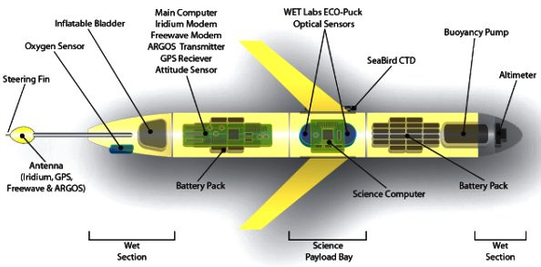

Company Name: **Boeing**

AUV Name: **Echo Voyager**

SPECIFICATION:

The **Echo Voyager** is an **Extra-Large Unmanned Underwater Vehicle (XLUUV)** developed by **Boeing** for long-duration missions in the deep ocean. It has a maximum operational depth of **11,000 meters**, a length of **15.5 meters**, a diameter of **2.6 meters**, and weighs **50 tons**. The Echo Voyager can operate autonomously for **several months** without human intervention. It is primarily used for deep-sea exploration, subsea infrastructure inspection, and data collection for military and scientific applications.

|  |  |  |  |  |  |  |
| --- | --- | --- | --- | --- | --- | --- |
| Maximum Depth | Length | Height | width | speed | Propulsion Type | Weight |
| 3,352 meters | 15.5 meters | 2.6 meters | 2.6 meters | 8 knots | Hybrid | 50 tons |

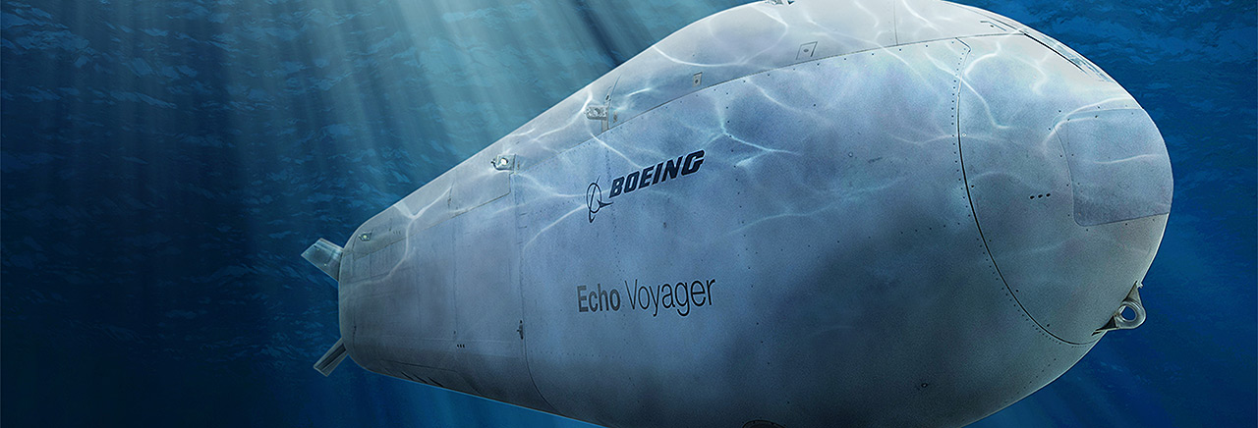

Company Name: **Qingdao Pengpai Ocean Exploration Technology Co., Ltd.**

AUV Name: **PX-900**

SPECIFICATION:

|  |
| --- |
| Designed for deep-sea exploration and data collection. |

|  |  |  |  |  |  |  |
| --- | --- | --- | --- | --- | --- | --- |
| Maximum Depth | Length | Height | width | speed | Propulsion Type | Weight |
| 6,000 meters | 6 meters | Not specified | 0.9 meters | 6 knots | Hybrid | 2 tons |

Company Name: **Woods Hole Oceanographic Institution**

AUV Name: **SeaBED**

SPECIFICATION:

The **Echo Voyager** is an **Extra-Large Unmanned Underwater Vehicle (XLUUV)** developed by **Boeing** for long-duration missions in the deep ocean. It has a maximum operational depth of **11,000 meters**, a length of **15.5 meters**, a diameter of **2.6 meters**, and weighs **50 tons**. The Echo Voyager can operate autonomously for **several months** without human intervention. It is primarily used for deep-sea exploration, subsea infrastructure inspection, and data collection for military and scientific applications.

|  |  |  |  |  |  |  |
| --- | --- | --- | --- | --- | --- | --- |
| Maximum Depth | Length | Height | width | speed | Propulsion Type | Weight |
| 2,000 meters | 2 meters | 1 meters | 1 meters | 1 knots | Electric | 200kgs |

Company Name: **Teledyne Webb Research**

AUV Name: **Slocum Glider**

SPECIFICATION:

|  |  |  |  |  |  |  |
| --- | --- | --- | --- | --- | --- | --- |
| Maximum Depth | Length | Height | width | speed | Propulsion Type | Weight |
| 1,000 meters | 1.5 meters | 0.21 meters | 0.21 meters | 0.5 knots | Buoyancy-driven | 54kgs |

Company Name: **National Oceanography Centre (UK)**

AUV Name**: Autosub Long Range (ALR)**

SPECIFICATION:

|  |  |  |  |  |  |  |
| --- | --- | --- | --- | --- | --- | --- |
| Maximum Depth | Length | Height | width | speed | Propulsion Type | Weight |
| 6,000 meters | 7 meters | 0.9 meters | 0.9 meters | 0.4 knots | Electric | 1800kgs |

Company Name: **Massachusetts Institute of Technology (MIT)**

AUV Name**: Jaguar**

SPECIFICATION:

|  |  |  |  |  |  |  |
| --- | --- | --- | --- | --- | --- | --- |
| Maximum Depth | Length | Height | width | speed | Propulsion Type | Weight |
| 6,000 meters | 2 meters | 0.5 meters | 0.5 meters | 2 knots | Electric | 200kgs |

Company Name: **Hydroid, Inc.**

AUV Name**: REMUS 6000**

SPECIFICATION:

|  |  |  |  |  |  |  |
| --- | --- | --- | --- | --- | --- | --- |
| Maximum Depth | Length | Height | width | speed | Propulsion Type | Weight |
| 6,000 meters | 3.84 meters | 0.71 meters | 0.71 meters | 4 knots | Electric | 862kgs |

Company Name: **Monterey Bay Aquarium Research Institute (MBARI)**

AUV Name**: Dorado**

SPECIFICATION:

|  |  |  |  |  |  |  |
| --- | --- | --- | --- | --- | --- | --- |
| Maximum Depth | Length | Height | width | speed | Propulsion Type | Weight |
| 1,500 meters | 4 meters | 0.53 meters | 0.53 meters | 3 knots | Electric | 1200kgs |

Company Name: **Lockheed Martin**

AUV Name**: AUSS (Autonomous Underwater Surveillance System)**

SPECIFICATION:

|  |  |  |  |  |  |  |
| --- | --- | --- | --- | --- | --- | --- |
| Maximum Depth | Length | Height | width | speed | Propulsion Type | Weight |
| 6,000 meters | 5.8 meters | 0.53 meters | 0.53 meters | 4 knots | Electric | 1200kgs |

Company Name: **Anduril Industries**

AUV Name**: Ghost Shark**

SPECIFICATION:

|  |  |  |  |  |  |  |
| --- | --- | --- | --- | --- | --- | --- |
| Maximum Depth | Length | Height | width | speed | Propulsion Type | Weight |
| 3,000 to 6,000 meters | 5.8 meters | 0.53 meters | 0.53 meters | 4 knots | Electric | 1200kgs |

Company Name: **Manta Ray**

AUV Name**: DARPA**

SPECIFICATION:

|  |  |  |  |  |  |  |
| --- | --- | --- | --- | --- | --- | --- |
| Maximum Depth | Length | Height | width | speed | Propulsion Type | Weight |
| 6,000 meters | 5.8 meters | 0.53 meters | 0.53 meters | 4 knots | Electric | 200kgs |

Company Name: **BAE Systems in collaboration with Cellula Robotics**

AUV Name**: Herne XLAUV**

SPECIFICATION:

|  |  |  |  |  |  |  |
| --- | --- | --- | --- | --- | --- | --- |
| Maximum Depth | Length | Height | width | speed | Propulsion Type | Weight |
| 3,000 meters | 12 meters | Not specified | Not specified | 4 knots | Hydrogen fuel cells | Not specified |

Company Name: **Teledyne Marine**

AUV Name**: SeaRaptor**

SPECIFICATION:

|  |  |  |  |  |  |  |
| --- | --- | --- | --- | --- | --- | --- |
| Maximum Depth | Length | Height | width | speed | Propulsion Type | Weight |
| 6,000 meters | 12 meters | 5.8 meters | Not specified | 4 knots | Battery-powered | 1500kg |

Company Name: **Joint Sino-Russo team (702nd Institute and SIoA)**

AUV Name**: CR-01A**

SPECIFICATION:

|  |  |  |  |  |  |  |
| --- | --- | --- | --- | --- | --- | --- |
| Maximum Depth | Length | Height | width | speed | Propulsion Type | Weight |
| 6,000 meters | 4.374 meters | 0.93 meters | 0.8 meters | 2 knots | Not specified | 1305kgs |

Company Name: **Joint Sino-Russo team (702nd Institute and SIoA)**

AUV Name**: CR-02**

SPECIFICATION:

|  |  |  |  |  |  |  |
| --- | --- | --- | --- | --- | --- | --- |
| Maximum Depth | Length | Height | width | speed | Propulsion Type | Weight |
| 6,000 meters | 4.5 meters | Not specified | 0.8 meters | 2.3 knots | Not specified | 1.5 tons |

Company Name: **China Ocean Mineral Resource Research and Development Association, China**

AUV Name**: Sea Dragon-1 ROUV**

SPECIFICATION:

|  |  |  |  |  |  |  |
| --- | --- | --- | --- | --- | --- | --- |
| Maximum Depth | Length | Height | width | speed | Propulsion Type | Weight |
| 3,500 meters | 3.17 meters | 2.24 meters | 1.81 meters | 3.3 knots | 100 SHP propulsion system | 3.45 tons |

Company Name: **China Ocean Mineral Resource Research and Development Association, China**

AUV Name**: Sea Dragon-2 ROUV**

SPECIFICATION:

|  |  |  |  |  |  |  |
| --- | --- | --- | --- | --- | --- | --- |
| Maximum Depth | Length | Height | width | speed | Propulsion Type | Weight |
| 3,500 meters | 3.8 meters | 1.8 meters | 1.8 meters | 3.3 knots | 125 SHP propulsion system | 3.45 tons |

Company Name: **Perry Tritech**

AUV Name**: Scorpio 45**

SPECIFICATION: Work-class ROV used by navies for submarine rescue services.

|  |  |  |  |  |  |  |
| --- | --- | --- | --- | --- | --- | --- |
| Maximum Depth | Length | Height | width | speed | Propulsion Type | Weight |
| 1,000 meters | 2.75 meters | 1.8 meters | 1.8 meters | 4 knots | Not specified | 1650kgs |

Company Name: **Perry Tritech**

AUV Name**: Super Scorpio**

SPECIFICATION: Work-class ROV used by navies for submarine rescue services.

|  |  |  |  |  |  |  |
| --- | --- | --- | --- | --- | --- | --- |
| Maximum Depth | Length | Height | width | speed | Propulsion Type | Weight |
| 1,520 meters | 2.43 meters | 1.22 meters | 1.22 meters | 4 knots | Not specified | 2040kgs |

Company Name: **Monterey Bay Aquarium Research Institute (MBARI)**

AUV Name**: Long-Range Autonomous Underwater Vehicle (LRAUV)**

SPECIFICATION:

The **Long-Range Autonomous Underwater Vehicle (LRAUV)**, developed by the Monterey Bay Aquarium Research Institute (MBARI), is designed for extended-duration missions to monitor and explore oceanic environments. This AUV enhances the capabilities of autonomous platforms by enabling long-distance travel and prolonged observation periods.

|  |  |  |  |  |  |  |
| --- | --- | --- | --- | --- | --- | --- |
| Maximum Depth | Length | Height | width | speed | Propulsion Type | Weight |
| 1,200 meters | 2.3 meters | 1.22 meters | 1.22 meters | 2 knots | highly energy-efficient propeller-driven system, | 100kgs |

Company Name: **Exail**

AUV Name**: A6K Autonomous Underwater Vehicle (AUV)**

SPECIFICATION:

The **A6K Autonomous Underwater Vehicle (AUV)**, developed by Exail, is engineered for ultra-deep-sea exploration and surveillance, capable of operating at depths of up to 6,000 meters.

The A6K is designed for a variety of missions, including underwater surveys, pipeline and subsea cable inspections, and search and rescue operations. Its hovering capability allows for precise low-altitude maneuvers, essential for detailed inspections and data collection.

|  |  |  |  |  |  |  |
| --- | --- | --- | --- | --- | --- | --- |
| Maximum Depth | Length | Height | width | speed | Propulsion Type | Weight |
| 6,000 meters | 5 meters | Not specified | Not specified | 3 knots | Not specified | 500kgs |